Lab 2 – Electric Fields and Potentials
Drawing maps for various charge distributions
This lab assignment is divided into two parts. In Part 1, you will predict the appearance of the electric field and the electric potential for 5 different charge distributions, based on the rules presented in the introductory readings. In Part 2, you will model these charge distributions in a PhET simulation to check your work. You will then finalize your visual representations by printing out your simulations and drawing a proper field-line representation on top of them.

Part 1 – Predicting fields and potentials

For each of the scenarios listed below (#1-5), you will first need to draw the charge distribution (locations and signs of charges) as described. Next, you will draw your predicted maps of the electric field lines and equipotential lines for that scenario. At a minimum, you must include 8-10 electric field lines (in blue or black ink) and 8-10 equipotential lines (in red or green ink), drawn in a representative way to appropriately show the symmetries of the situation.

Charge Distribution #1:
Two opposite charges of equal magnitude, placed 6 units apart along a horizontal line. The negative charge is on the left, and the positive charge is on the right.
Use the grid below to draw this charge distribution and the required lines.



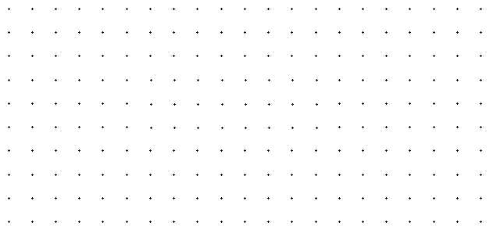

Charge Distribution #2:
Two negative charges of equal magnitude, placed 6 units apart along a horizontal line.
Use the grid below to draw this charge distribution and the required lines.

Charge Distribution #3:
Four charges (2 positive and 2 negative) of equal magnitude and located at four corners of a square – with like charges diagonally across from each other.
Use the grid below to draw this charge distribution and the required lines.

Charge Distribution #4:
Eight charges of equal magnitude (4 positive aligned vertically on the left side, and
4 negative aligned vertically on the right side, so opposites “face” each other across).
Use the grid below to draw this charge distribution and the required lines.

Charge Distribution #5:
As shown in the diagram below. The ball and the bar are both conductors, which are charged according to the number of “+” or “-” signs indicated.
Use the diagram below to draw the required lines for the given charge distribution.

+

Part 2 – Simulating the charge distributions

For each of the five scenarios described in Part 1, you will now simulate the charge distribution and visualize the electric field and equipotential maps using the PhET simulation:
phet.colorado.edu/sims/html/charges-and-fields/latest/charges-and-fields_en.html
The electric field representation used here is a bit odd – it’s certainly not the electric field lines used elsewhere in this lab, but it’s also not the traditional electric field vectors that show field strength by the length of the vectors. Instead, field strength is shown here by fading-out vectors of a uniform length. You will rectify this issue by printing out your final simulations and then drawing a proper field-line representation on top of them.
Equipotential lines are added by moving the crosshairs of the equipotential tool to each desired location, and then clicking the pencil icon. A standard equipotential map would have these lines equally spaced in voltage, but here that would be up to you.
Beware: If you hit the erase button, or if you move any one of your charges, all of your equipotential lines will disappear!
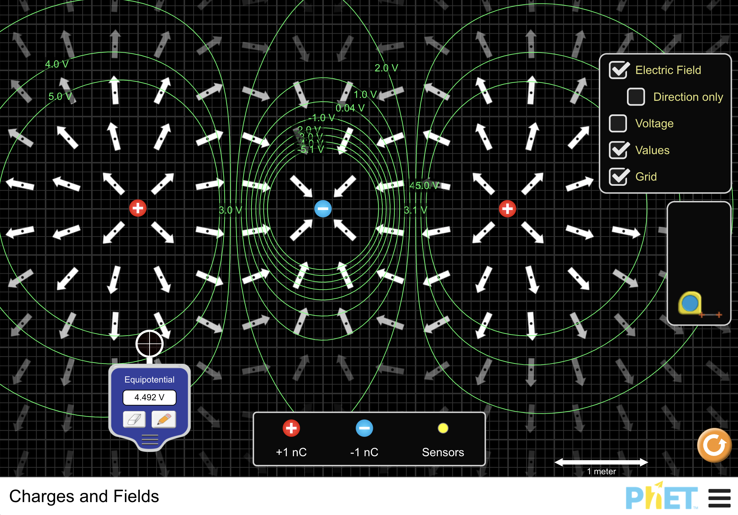

After simulating each of the 5 charge distributions in PhET, it’s a good idea to take screenshots of your work to save for later. This will allow you to refer to the simulated electric field vectors when you draw your own electric field lines. These screenshots do not need to be submitted with your lab report.
However, you do need to print out your simulations, hand-draw your final electric field line visualizations on top, and then submit them with your lab report. Getting this into the right format is tricky, so here are the steps to make that easy:
- Uncheck the Grid option in the simulation. This will clean up your print-outs significantly. You may want to uncheck Values as well, but that’s up to you.
- Press Ctrl+P in Windows (or ⌘ Cmd+P on a Mac) to open the Print dialog, and then either print or save your simulation. This will replace the black background with a white one, which will be vital for what comes next.
- Your print-out should initially look something like the first image below. The electric field vectors have disappeared (they’re white-on-white), but you should still be able to see the charges and the equipotential lines.
- Draw at least 8-10 electric field lines (in blue or black ink) on top of your print-outs, in a representative way to appropriately show the symmetries of the situation. Then “scan” and submit them with the rest of your lab report. Your final result should look something like the second image below.
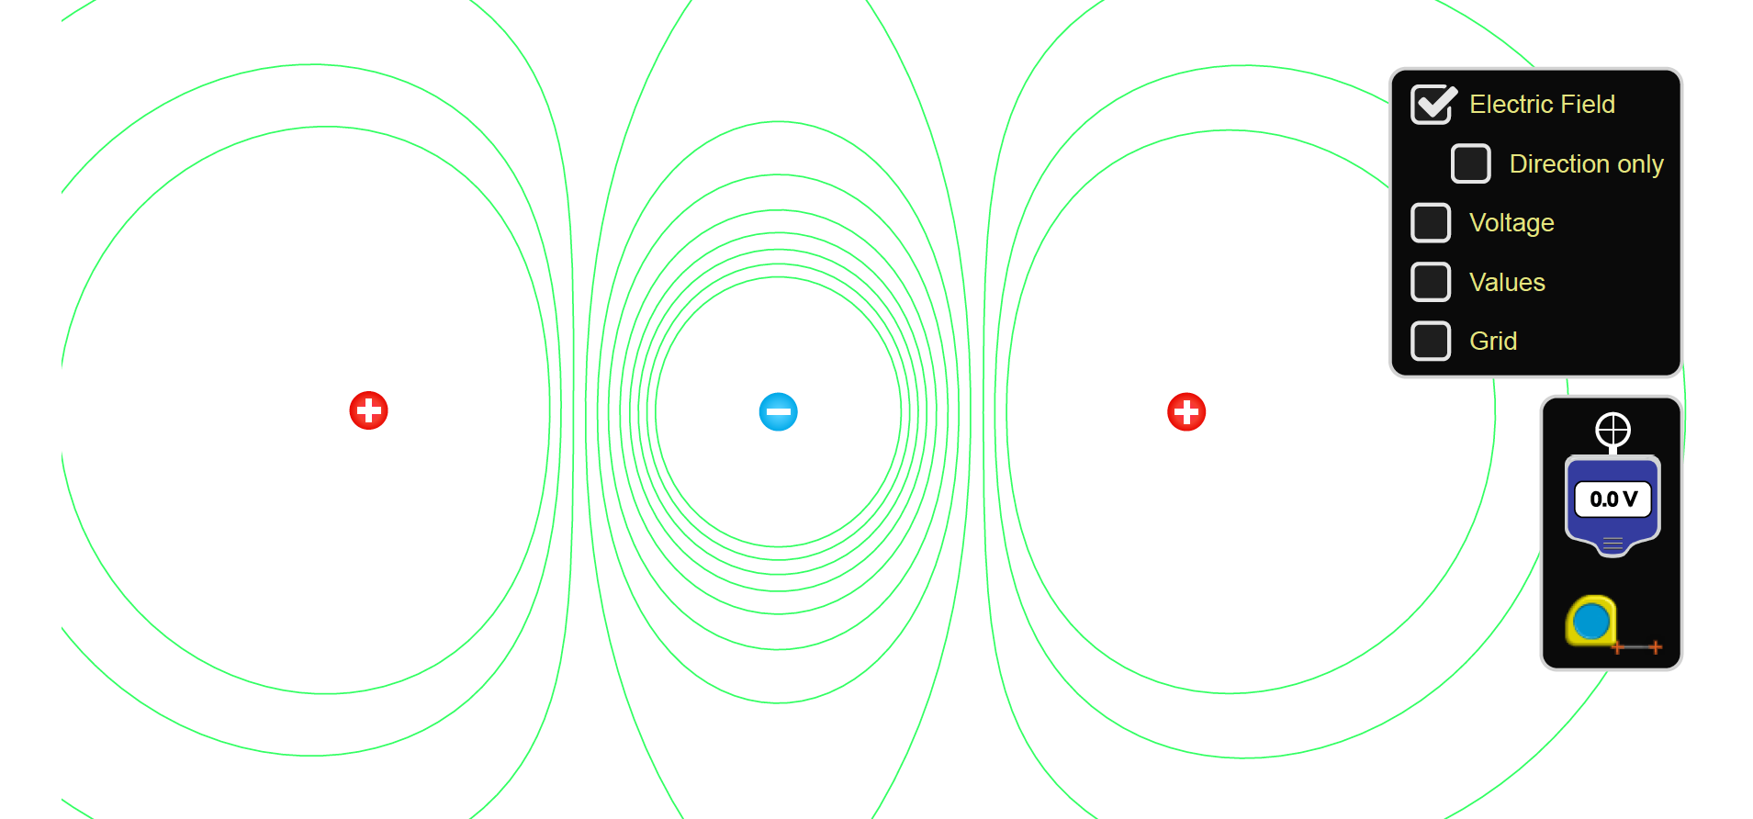
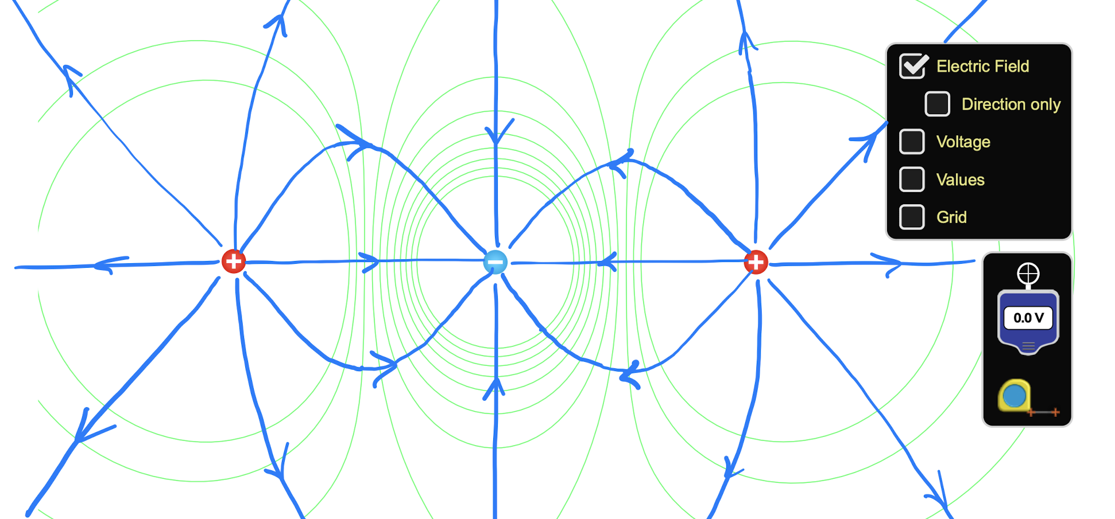
Concluding Questions

- How do your final visualizations from Part 2 compare with your initial predictions from Part 1? Have they changed significantly? How so?

- State what you have learned about the nature of the electric potential for point charges from this exercise.

- Two charges are placed along a horizontal x-axis: –1.0 nC at x = -0.50 m, and +5.0 nC at x = 1.0 m. Set up the equations and “do the math” to find the position in the x-y plane where their net electric field E = 0. Show all work.

- Place the aforementioned charge distribution into the PHET simulation, and include a screenshot of your simulation with this lab report. Is the electric field equal to zero where you predicted it would be? Also, explore the electric field in the immediate area around this spot. Which direction does the field point if you move a bit to the left of this spot? If you move a bit to the right? If you move a bit up? If you move a bit down?

